Exercise 5 Documentation

1. 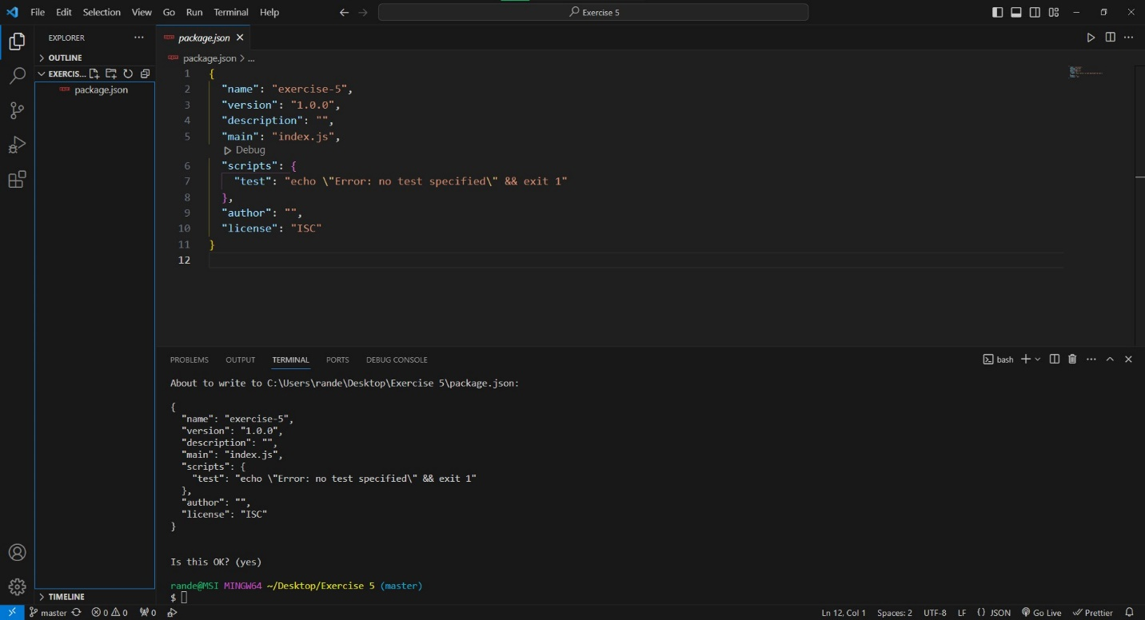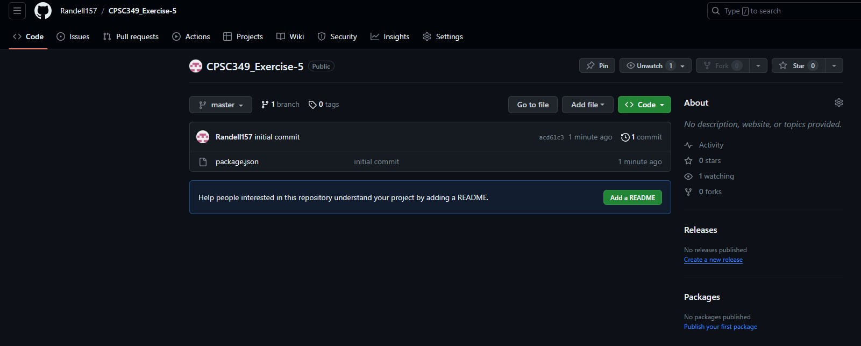To start the exercise, I first initialized both a new Github repository using git init and a new NPM project using npm init.
2. I then installed the 3 NPM modules as dev dependencies.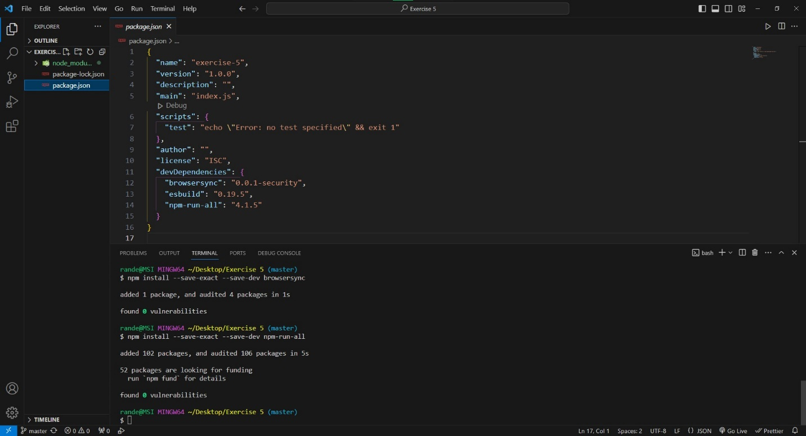
3. After that, I downloaded Pocketbase and put the executable file into the root repository. A screenshot of a computer

   Description automatically generated
4. I then created both the pb_public and src folders
5. Then added the index.html and app.jsx files to their respective folders.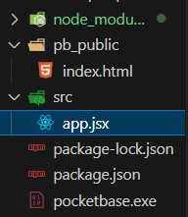
6. I then added the CDN links for React. However, I also saw that the CDN links were apart of the legacy react page, so I decided to npm install react react-dom. (Not sure if this was required though) 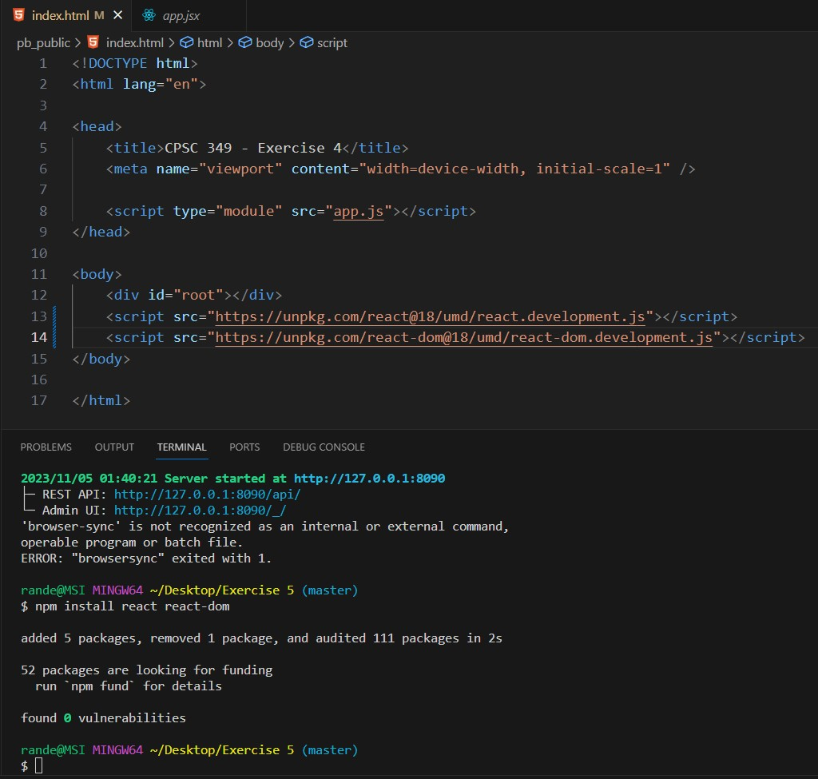
7. For the Pocketbase Javascript SDK, I downloaded one of the files from the Github page in the dist folder and put the file into the root folder. A computer screen with text on it

   Description automatically generated
8. I then added the 4 npm scripts to the package.json file. A screen shot of a computer

   Description automatically generated
9. When trying to run the command npm start, I got these two errors. For the browser-sync error, I may have installed the wrong browser-sync as there is both browsersync and browser-sync. So, I installed the correct one. As for the ./pocketbase serve not working, I removed the ./ from the line and that seemed to fix my issue. A black screen with white text

   Description automatically generated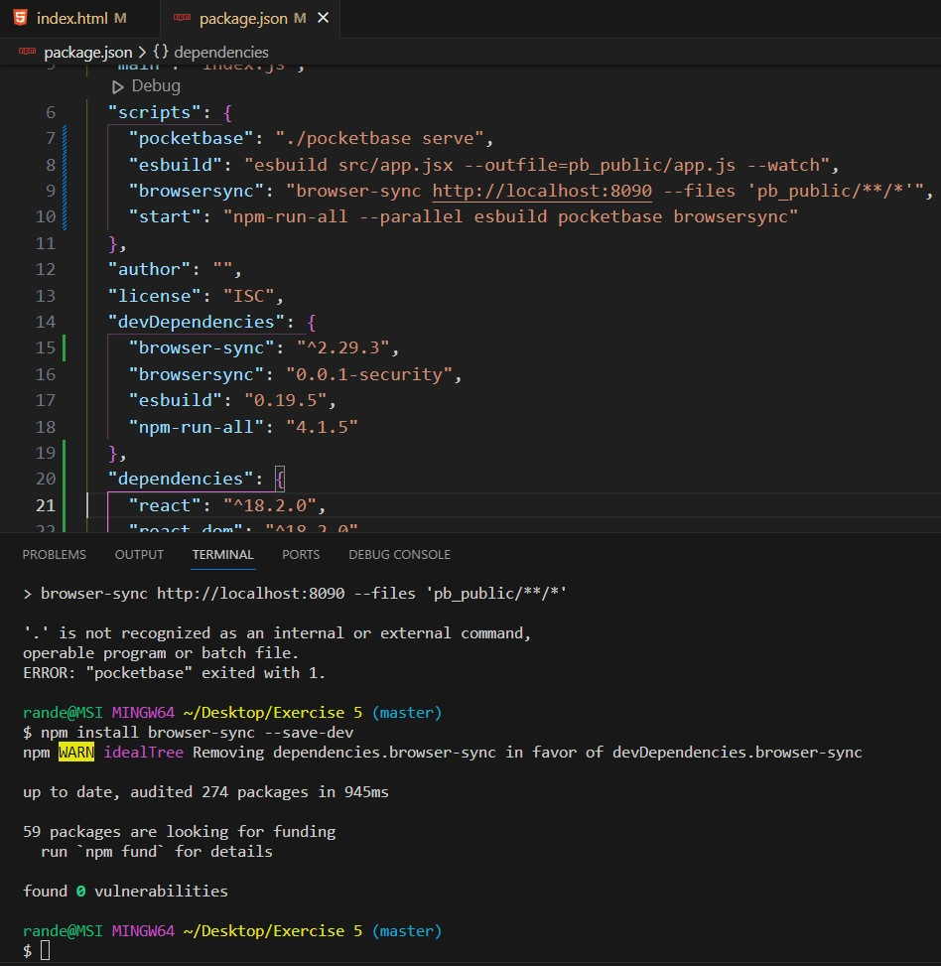



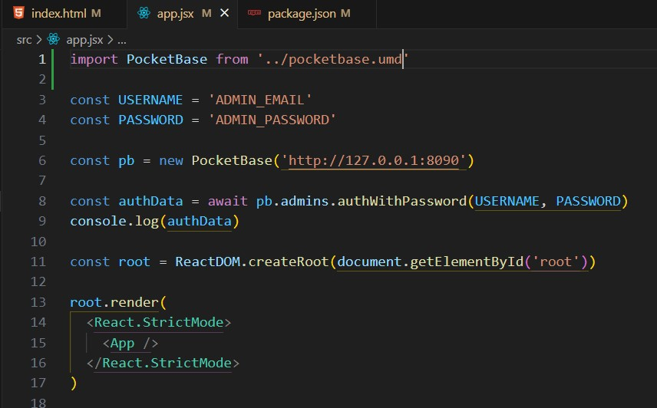However, I stumbled into another problem, where I would get two errors within the devtools of my browser. I fixed one of them by putting an import in the app.jsx file to define the PocketBase. As for the other error, I decided to npm install pocketbase –save to get the pocketbase files onto the node folder

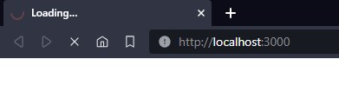Also, when trying to load the localhost:3000, it would not load any page. Not sure if that is due to my computer or the code.

After many hours of trial and error, I decide to instead of using the pocketbase npm, I used a pocketbase cdn onto the html file and removed the import from the app.jsx file.This lead to the authentication error I needed to get to proceed to the next step!



1. I went to the PocketBase Admin UI and filled out the email and password. Then I used that same login and modified the app.jsx file with the same credentialsA screenshot of a computer

   Description automatically generatedA screenshot of a computer

   Description automatically generated
2. After reloading the :8090 page, I finally get the result needed to complete the assignment!

Throughout this assignment, the biggest challenge for me was figuring out step 7. I tried to do many things, such as:

1. Download each pocketbase sdk js file and import it through the html file, the app.jsx file, or both at the same time. (didn’t work)
2. Use npm install pocketbase –save to have my own copy of each pocketbase js sdk and import them the same way. (didn’t work)

The only way I got it to work was to look up the pocketbase cdn and use the link from https://cdnjs.com/libraries/pocketbase/0.8.0-rc1 as a src for the html without importing within app.jsx.

Github: https://github.com/Randell157/CPSC349_Exercise-5